Phase 2
Reconnaissance Report

Objective
The Objective of the Reconnaissance is to gather OPEN-Source Intelligence on the Target Website. The focus was to identify domain information, subdomains, exposed services, and publicly visible assets.

Tools used
- Whois
- Sublist3r
- shodan
- wappalyzer

Methodology
The target we used for this OSINT exercise was juice-shop.herokuapp.com
- Domain Look up information Who is:
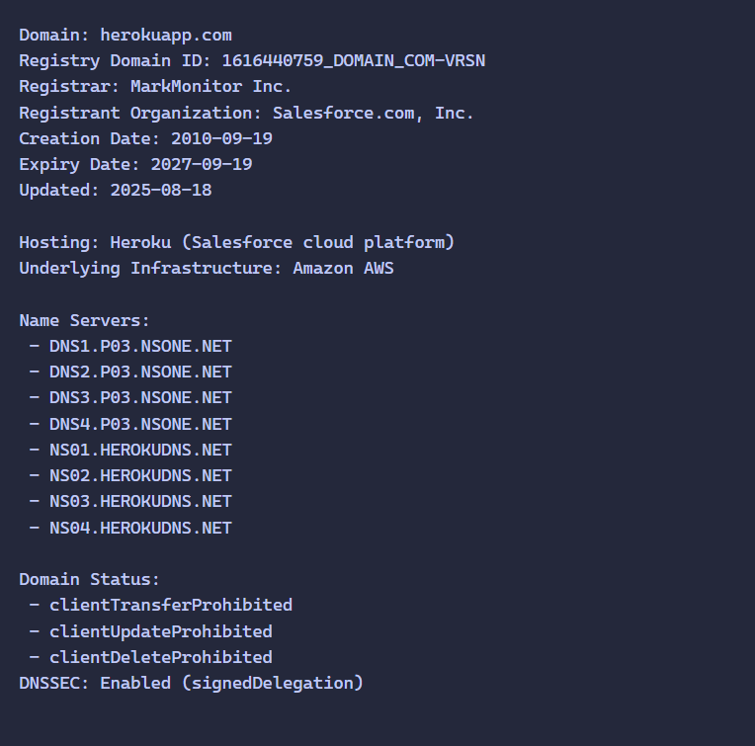

- Subdomain Enumeration:
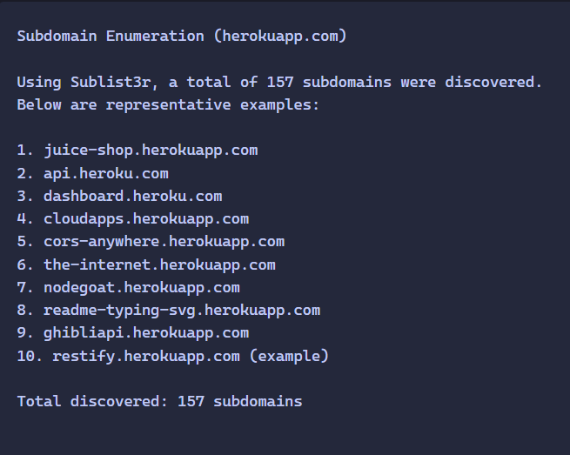
- Services Exposed:
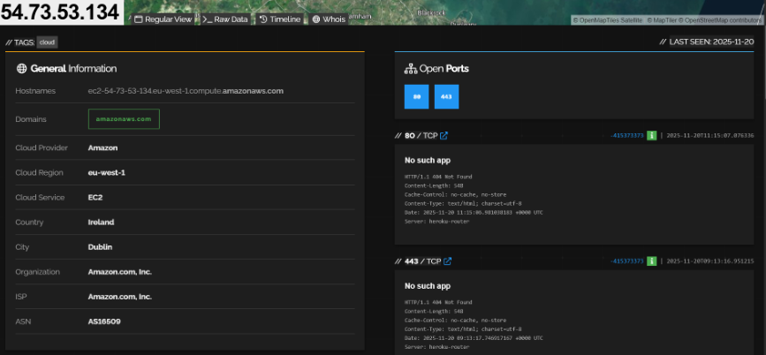

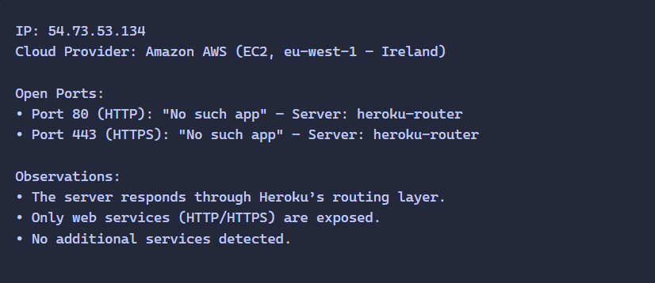
- Wappalyzer Technologies
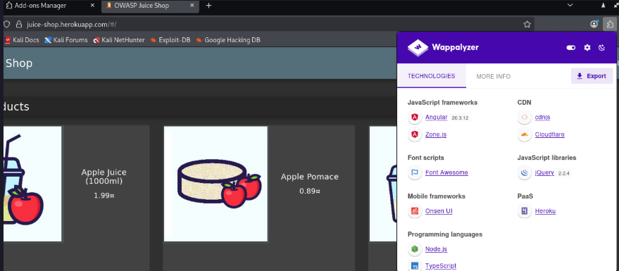
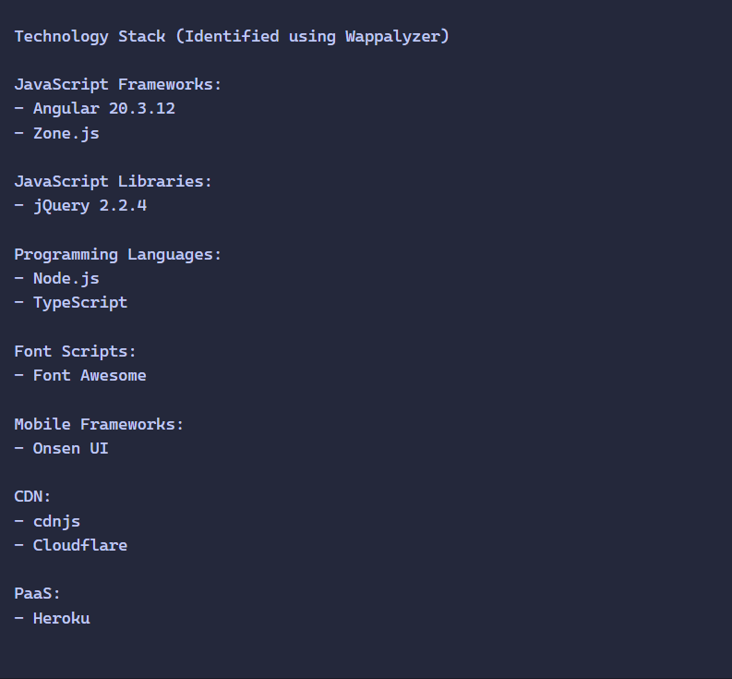

- Asset Mapping

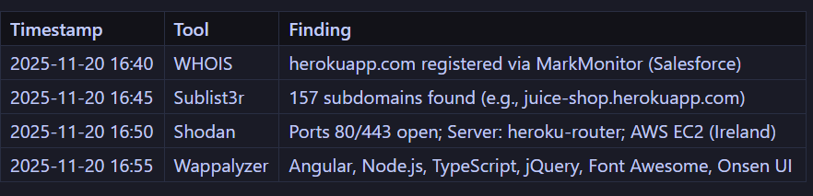

Findings summary (Recon Summary).
The reconnaissance exercise revealed a lot of key information regarding domain ownership, Creation date, etc. Also were able to enumerate around 157 subdomains using sublist3r tool and a sample of those subdomains were presented for demonstration purposes. Shodan also revealed Key information regarding the targeted website like where is the place of the webserver who is hosting the webserver (Cloudflare) and exposed services such as HTTP and HTTPS. Using the Paralyzer Extension, we were able to identify the technologies used to build the website (Target Host) which could be further enumerated for outdated technologies for better chance at successful penetration test.

